* It will have read locations at multiple places as it was replicated. 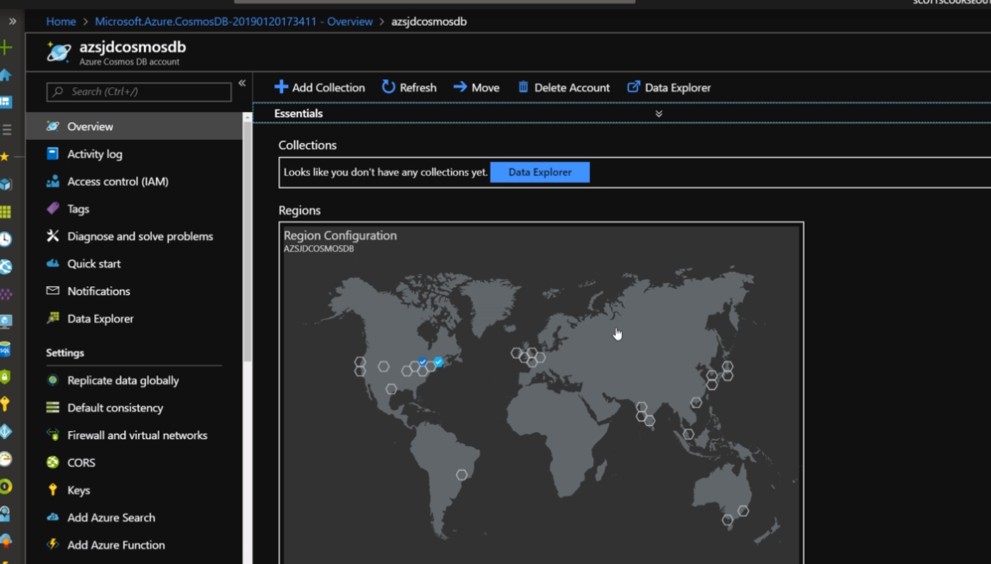
* You can have data replication at other places as per the collection cluster.
* 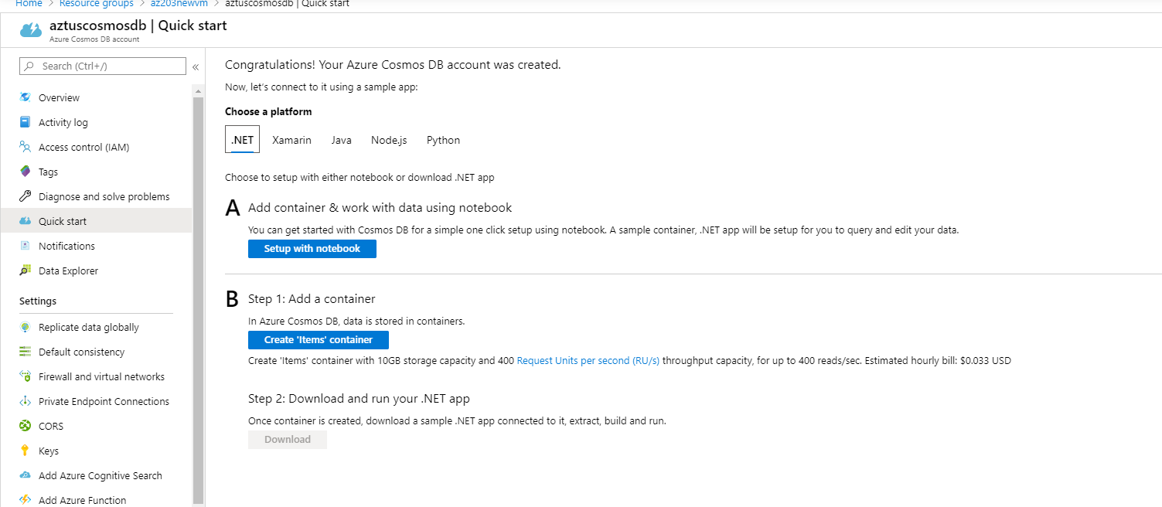
* Create a database and put a collection inside it.
* Adding collection would ask you to add a database.
* Adding a database container for collection 